Groton Dunstable SEPAC Presents
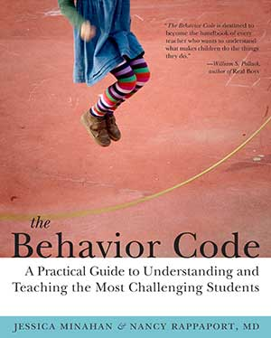
Effective Strategies for Students
with Anxiety Related Behavior
Jessica Minahan, M.Ed., BCBA

Wednesday, November 16, 2016
6:00 P.M. – 8:00 P.M.
Groton Dunstable Regional Middle School PAC
344-346 Main Street
Groton, MA
Free admission courtesy of GD SEPAC. Donations welcome.

https://gdsepac.wordpress.com/
Presenter: Jessica Minahan, M.Ed., BCBA
Jessica Minahan, M.Ed., BCBA is a board certified behavior analyst, special educator and international speaker and consultant. She is a blogger on the Huffington Post and the author of The Behavior Code with Nancy Rappaport, and The Behavior Code Companion (jessicaminahan.com)
About this Event
The National Institutes of Health (NIH) reports that one in four thirteen-eighteen year olds has had an anxiety disorder in their lifetime. Without intervention, these children are at risk for poor performance, diminished learning, and social/behavior problems in school. Understanding the role anxiety plays in a student’s behavior is crucial and using preventative strategies are key to successful intervention. Effective behavior plans for these students must avoid the reward and punishment-based consequences from traditional behavior plans and focus instead on the use of preventative strategies and on explicitly teaching coping skills, self-monitoring, and alternative responses.

